Le Ron Carlton

Udacity Data Analytics Program

DCT Columbus

Project 4 – Airline Data

Insight 1 – Are delays and late flights common?

<https://public.tableau.com/views/On-TimeFlights_16216699354990/On-TimeFlights?:language=en&:display_count=y&publish=yes&:origin=viz_share_link>

Flight delays are part of air travel in the modern era. We will evaluate the data to determine if flight delays are challenges facing specific airlines, or if it is an issue that is industry wide.

The top chart detailed the total number of flights by airlines sorted by largest number of flights by airline first. Utilizing a filter, we can highlight specific airlines, and examine airline VA and compare it to other airlines like WN. We can see that the airline WN, has a total of 1,261,855 flights, but only 19,452 are on time. As we continue down the line of number of flights by individual airline, we see similar trends where a small number of flights are on-time consistently. This leads us to understand the flight delays are an issue across the industry, and not limited to a specific airline.

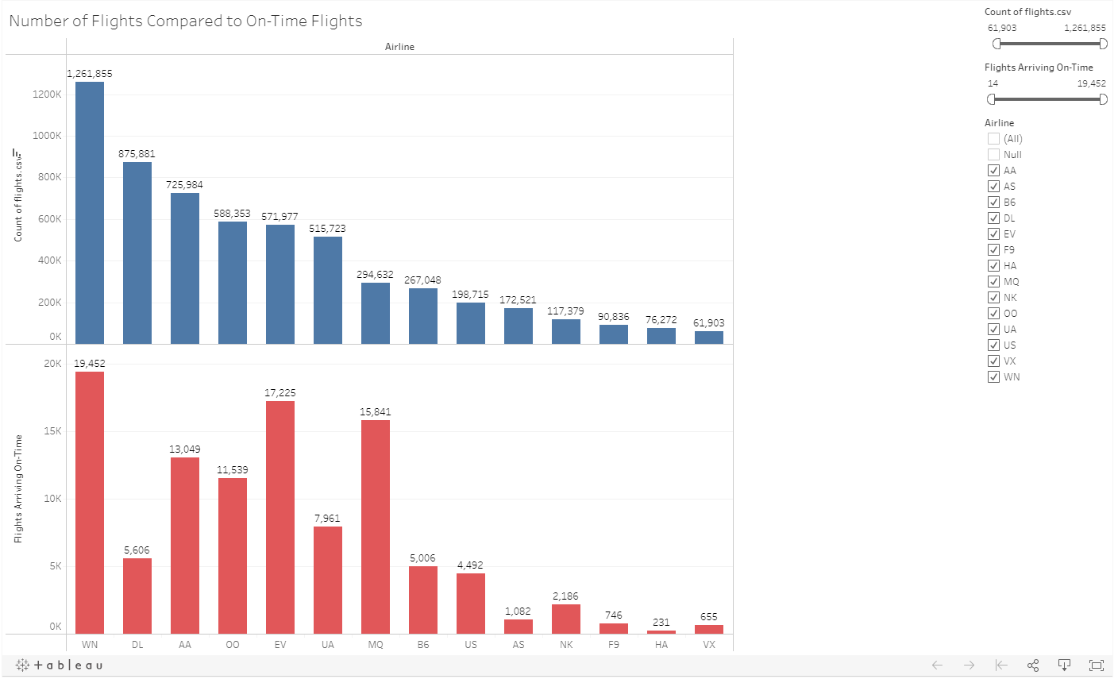

### Insight 2 – What cities on average have long weather delays?

<https://public.tableau.com/views/WeatherDelaysByState-UdacityDataAnalyticsProject4/WeatherDelayDashboard?:language=en&:display_count=y&publish=yes&:origin=viz_share_link>

Weather delays have an impact on travelers, airlines, and airports with schedule impacts to all parties. To better understand what areas, have lengthy delays, frequency, and more, we can evaluate the data on this topic.

The map gives us a regional relation to the weather, noted by the proximity to bodies of water, and a higher, colder climate. Additionally, we can see that in all charts Marquette, MI has the longest weather delays average around 168 minutes; two times the next lengthiest average delay in Key West.

### **Insight 3** – What states have the most average security delays compared to total number of flights?

<https://public.tableau.com/shared/YTFF7FNQP?:display_count=y&:origin=viz_share_link>

For this Dashboard, we evaluate the monthly impact of security delays by city and compare that to the number of flights by 1000. We evaluate the data and determine that the most security delays occur during November.

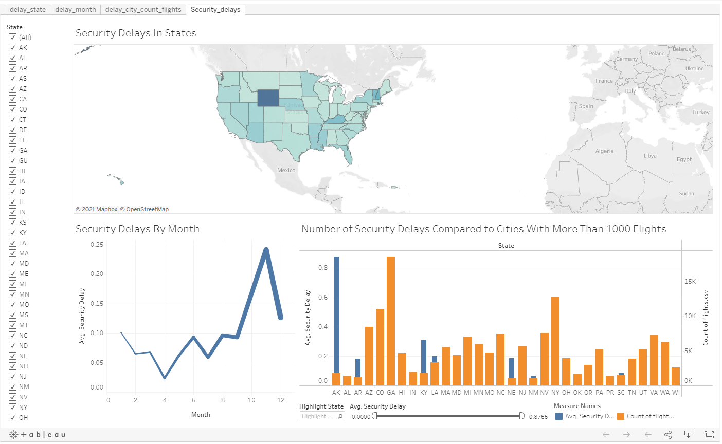

We additionally can determine that Alaska has the highest average security delays while having an average of 1771 flights a year. This would lead us to believe that having a higher average amount of security delays is not related to the number of average flights as Georgia has the highest number of flights.

Design Notes: With this visualization I sought to present the data first with the map, as I felt Alaska being a low population state, but with high security delays would be a strong visual point. Using the line chart to display months, I selected to have the chart not only move vertically to indicate the delay, but also for the line to grow with the added tooltip towards the end of the year to contrast what is traditionally thought of as a busy flight time that would correspond with delays. The data shows that is not the case. In the final slide comparing 1000 flights minimum, I sought to limit the data to 1000 or more flights, while also changing the size and colors of the bars to contrast the data points.